

KAN Vocals
Mob - 07863350324
Kan4real@hotmail.com

11th September 2018
Dear Parent/Guardian

VOCAL TUITION - 21/9 28/9 5/10 12/10 (4 Sessions)
(PLEASE NOTE THAT KAN VOCALS WILL TAKE PLACE ON A FRIDAY - 3.20PM – 3.50PM)

I am pleased to inform you that I will be coming to St John’s again this term and will form KAN Vocals Choir. This Club is open to boys and girls in Y3, Y4, Y5 and Y6. This term the sessions will take place in the school hall from 3.20pm – 3.50pm on FRIDAYS. The children can make their way to the hall straight from their class at 3.15pm. There will be 4 (30 minute) sessions at £2 per session. Kindly pay £8 cash or cheque (made payable to KAN VOCALS) in advance of the lessons in a named envelope. Children may pay £2 prior to each session but children who have not paid will not be able to participate.

I am a past pupil of St John’s School and trained at the Academy of Contemporary Music in Guildford. I also teach at Dorchester and Weymouth Stagecoach Theatre Schools, All Saints C E School, Budmouth Technology College and Wey Valley. I have been DBS cleared. I will be working with the children on close harmony songs and will be teaching both breathing and vocal techniques. The styles I teach are pop, rock, R’n’B and Musical Theatre.

Kindly complete and return the slip below as soon as possible (by Thursday 20th September) to St John’s School Office in an envelope addressed to KAN VOCALS if you wish your child to participate.

Yours faithfully

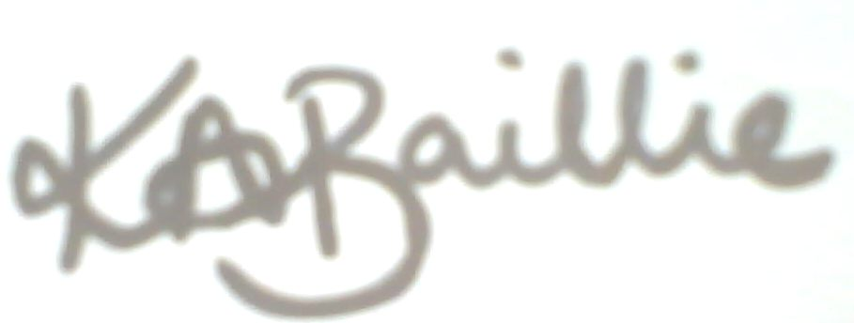
Kerrie-Ann Baillie
……………………………………………………………………………………………………………………….

PERMISSION SLIP – (KAN VOCALS)
VOCAL TUITION - 21/9 28/9 5/10 12/10 (4 Sessions)

Name …………………………………………………….. Class ……………………………………………..

My child would like to participate in KAN VOCALS on FRIDAYS from 3.20pm to 3.50pm with
Mrs K Baillie

*Please delete as appropriate

My child can walk home / I will collect my child from the hall at 3.50pm

I enclose £8 cash / cheque (cheque made payable to KAN VOCALS)

Signed…………………………………………………. Date ……………………………………....

